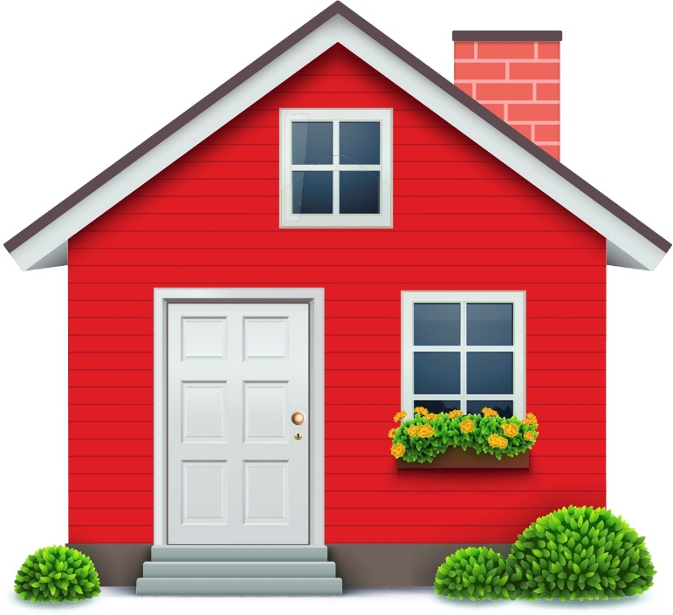

School at Home

School is different right now.

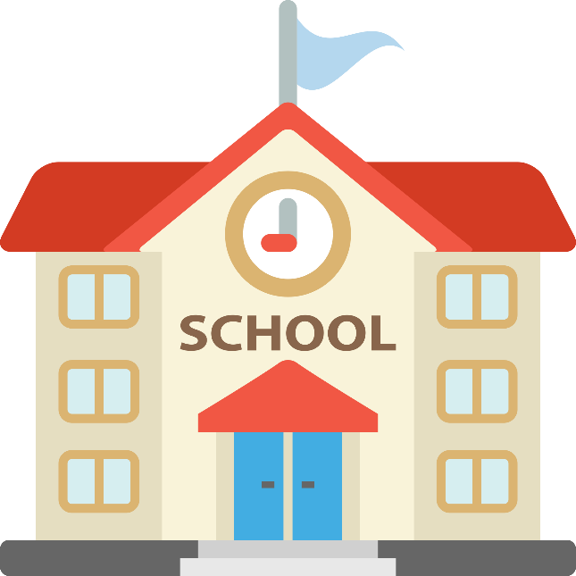

Instead of coming to school, you will be going to school at your house.
Because you are going to school at home, your schedule will be different.
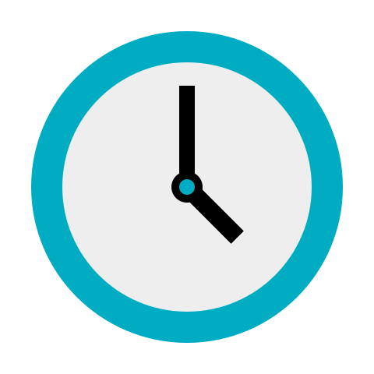
Activities will be done at different times at home.

Your school schedule will go back to normal when we return to school.

Just remember, your teachers miss you and cannot wait to see you at school!

